**AMERICAN INTERNATIONAL UNIVERSITY-BANGLADESH**

**Faculty of Science and Information Technology**

**SDPM PROJECT**

**SOFTWARE DEVELOPMENT PROJECT MANAGEMENT | FALL 2016-2017**

**Sec: [A]**

**Faculty Name:** S.M. ABDUR BHUIYAN ROUF

### SOFTWARE NAME:

### GLOBAL MEDICAL SYSTEM

### -------------------------------------

### Technology:

### Web

### Desktop

### Mobile phones/Handheld Devices

### Group Members

|  |  |  |  |  |
| --- | --- | --- | --- | --- |
| # | Name | ID | Signature | Department |
| 1 | Rahaman, Ashiqur | 14-27069-2 |  | CSSE |
| 2 | Khan, Muhit Mehedi | 13-24795-2 |  | SE |
| 3 | Mahmud, Md Shakil | 13-24696-2 |  | CSSE |
| 4 | Rahman, Md Farsha | 14-25540-2 |  | SE |

### 

### Global Medical System

**CONCEPT ELABORATION:**

Our system will work as a common platform for patients, doctors, pharmacies and medicine companies all are assigned to user. There are four kinds of user in our system. If the user is doctors then he/she have a personal account he can store all his medical related information like degrees, dept, he can add his chamber information, schedule and location in this account. From this system he can easily communicate with patients any emergency reasons. Doctors can update their schedule and chamber location to inform the patients. He can get reminder according to his schedule. From this system patients can get appointment to meet the doctor. Now if the user is patient he can get some options. Now he chooses what type of service he need. Our system has three special kind of service for all patients. Patients can search by a doctor’s name to know his location and details. The patient can also search by diseases name and the system will show the nearest doctor or an expert of that diseases. Emergency patient can get online treatment from doctor. Another special kinds of service for patient is search by medicine name and find out the nearest pharmacy list have available this medicine. Also see the medicine price and pharmacy rating. Now If the user is pharmacy, they get two types of service of our system. One is a sample inventory management system of a pharmacy other is online medicine order to the medicine company. The pharmacies can use the system to manage the medicines. Pharmacies can see the amount of a medicine they have, the age range for which the medicine is valid, alternative of a medicine, amount of medicine needed in the next time period etc. Pharmacies also get reminder if a medicine is short in number and can order the medicine from the companies. Patients can also search a medicine. Any kinds of emergency reasons pharmacy can order emergency medicine to the medicine company. The system can use the information of pharmacy inventory to find the nearest pharmacy where the medicine is currently available. The project is a combination of pharmacy management system and medicine searching system. The idea is that, the people will know which doctor he should go to and where to look for a specific medicine when he needs it. Doctors and pharmacies can manage their work easily while getting recognition in the medical market. The purpose of this project is to bring all the doctors, patients, pharmacies and medicine companies under a common network to make life easier and save our valuable time.

The project targets the doctors who want easier communication with patients, general people as patients who has internet access, pharmacies and medicine companies.

The project is innovative as it brings doctors, patients, pharmacies in one common platform for better communication. The project enables people to find medical support easily and very quickly. This idea is not present in the current market. This makes the project innovative and new.

Main purpose of this project is to find medical help for general people at any time anywhere.

**Feasibility Study:**

As per our project we want make the life of Doctors, patients and want to made a better communication system within Doctors, Patients, Pharmacists, and Companies. As per our solution their life will much easier than before. As we also discuss about this solutions and problems also after all that we decided on this system what we want to made. If you see our User case story and our activity diagram you will able to relate that we have a solid business model and as we also want to use web technologies and also desktop and Mobile apps version it will make easier for each of our users.

If you see our model you will understand that this is a costly project because we need a large number of manpower for this project. We need web developer, apps develop we need more men who will work on resource collections and so on. So this is a much costly project as you see.

If you search in the market you won’t get any type of software like this and this is most needy software as far as we discuss and talked about market. As you can see this is a basic platform from all doctors, Pharmacists, Patients, companies all of them in this they can communicate with each other easily and it will save their time which is most important thing.

**User Scenario:**

Mr. Hamid is a 45 year old senior citizen. He has been suffering from diabetes for last 5 years. Doctor has prescribed him some unique foreign branded medicine. It is hard for him to find all the medicine in his area. So he has to go all the way from banani to shahbag in order to get all the medicine. Though he is a senior citizen but he loves to use different mobile application. He wants a mobile/web application through which he can easily search the inventories of the nearest pharmacies from his house.

Since last 3-4 days he is having heavy pain in the left side of his chest. He wants to consult with Dr. Momenuzzaman who is one of best cardiologist in town. He wants to make an appointment to consult with Dr. Momenuzzaman. He wants to make it from home through his mobile phone. He also wants to find other cardiologist near him through the mobile application. So that he can compare between them by watching the patient review.

Dr. Momenuzzaman is a renowned cardiologist. For last couple weeks he his having some problem with his assistant Abdour Rahim. He figured out that Abdour Rahim is giving early appointment for patient by taking bribe. Dr. Momenuzzaman wants to fire Abdour Rahim for this hilarious work. But he also knows that he is totally dependent on his assistant as he has to maintain several chambers and consult with more than 100 patients every day. Abdour Rahim keeps track of all his chambers, routine, patient’s appointments, patient’s history and many more. He wants a mobile application where he can keep the list of his chambers, patient, and patient’s history. He is also curious to know how many patients he consults every day/week/month and he also wants to know from which chamber he consults most/least number of patient.

Mr. Rakib is pharmacy company owner and wants to increase the sale of his business. In order to meet the business goal, he wants to digitalize his pharmacy. He wants an inventory system where he can upload all the details of his medicines by using barcode scanner so that he can easily find in which place of the shelf his desired medicine is located by searching in the inventory system. He also wants to make the status of his inventory visible to all so that his customer can see which medicine has got in his inventory. He also wants the medical representatives to track down his inventory system so that they can easily fill it up.

Samson H. Chowdhury is the owner of square pharmaceutical company. Recently he is facing some problems with his medical representatives. As the number of pharmacy is increasing, so the medical representatives have to work harder to keep track and refill the inventories of too many pharmacies. So he comes up with the idea of a web application where a small team will keep tracking all the pharmacies inventory from the headquarter and refill their inventories fast. He also wants to add some features like knowing the best pharmacy, bills per month for pharmacy and by basing on these factors he wants to give some award to the pharmacy.

**Use case diagram:** 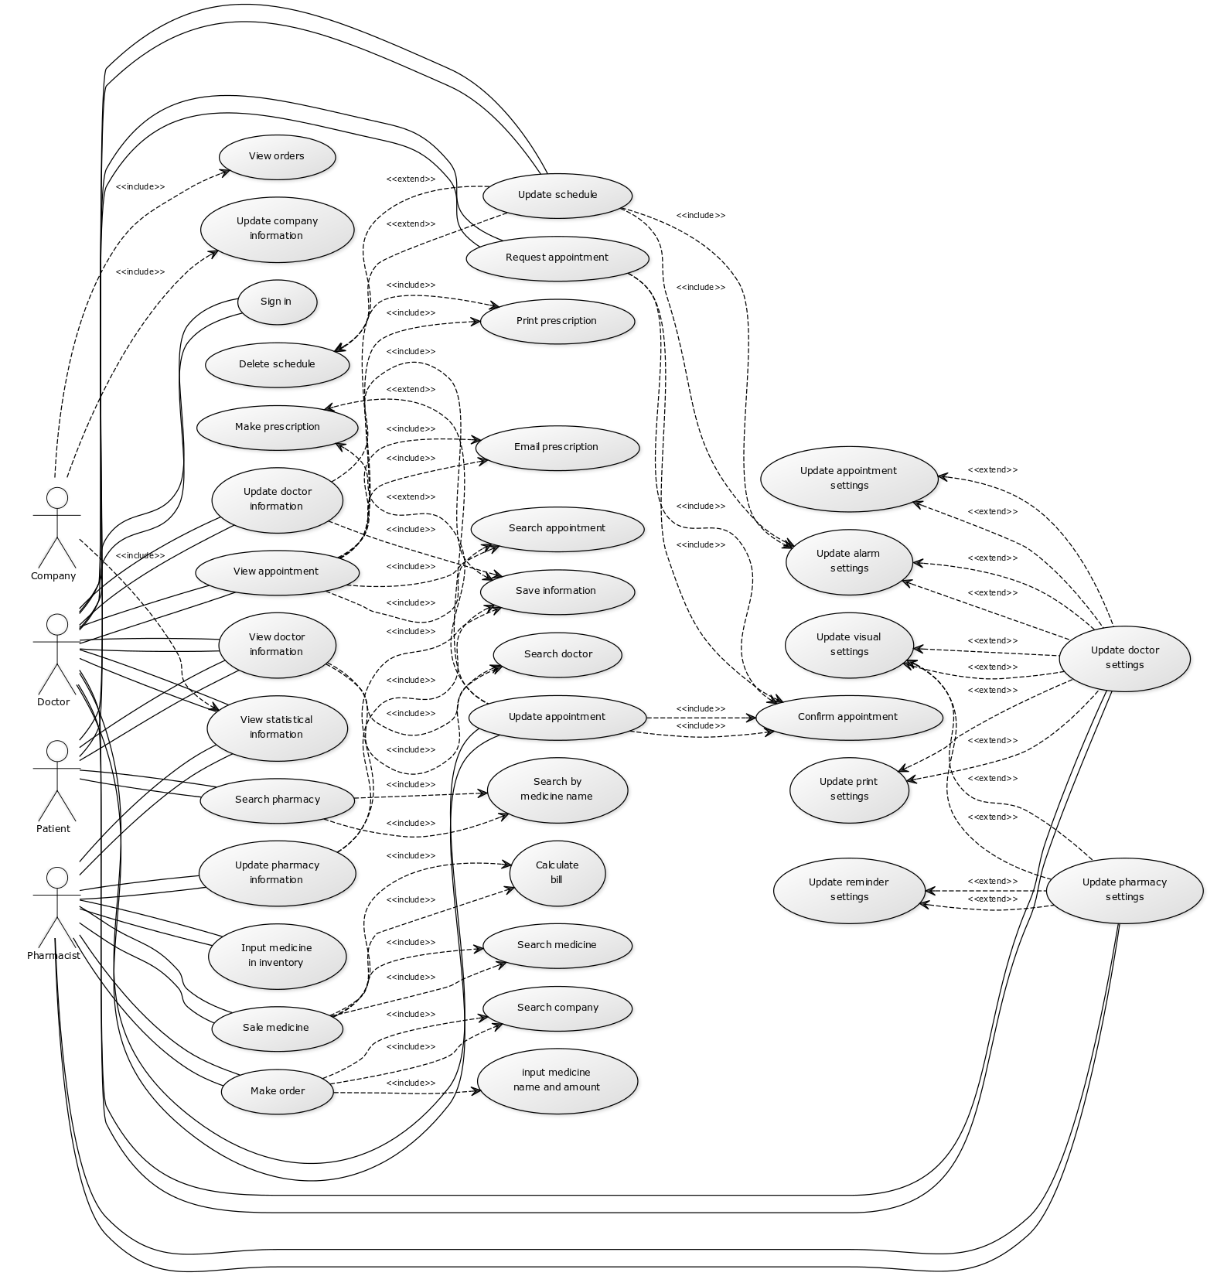

**Use case diagram:**

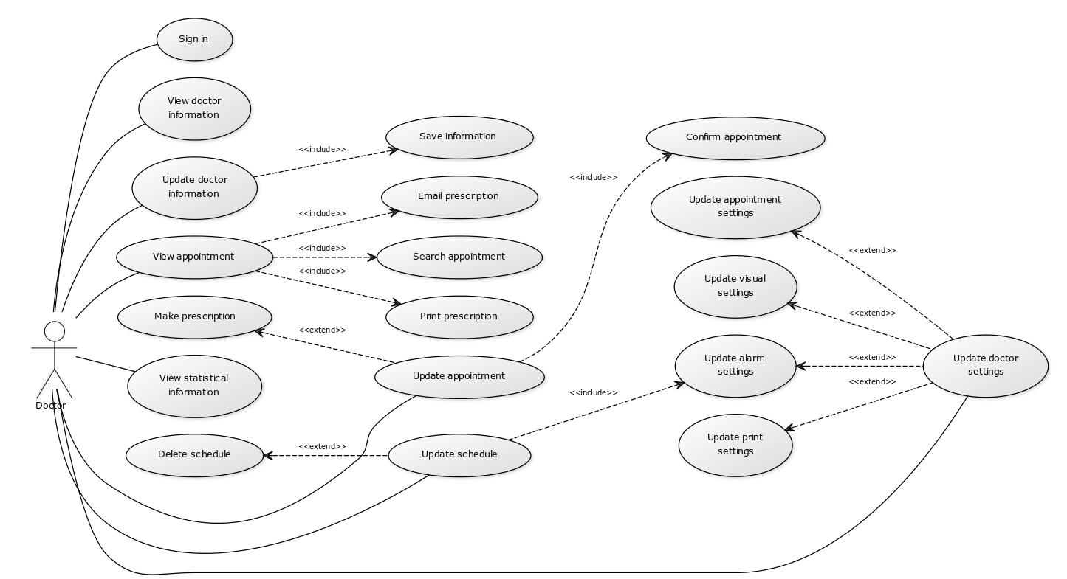

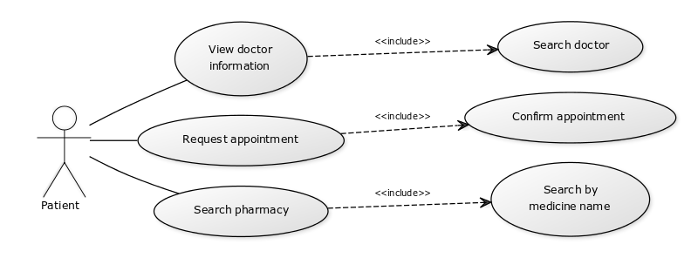

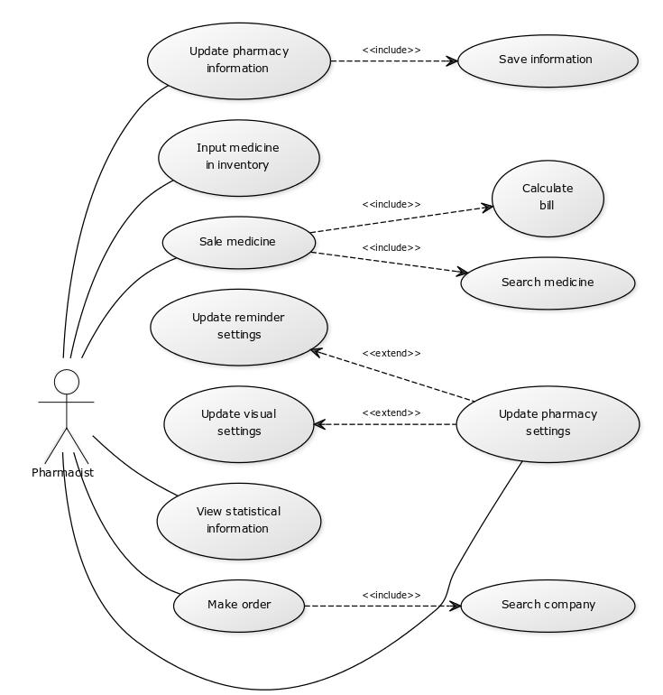

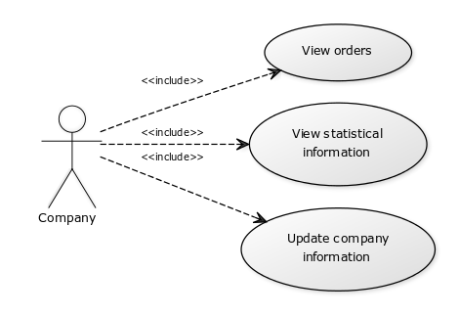

**User story:**

1. As a doctor I want to log in so that I can have access to my account.
2. As a doctor I want to make prescription so that I can keep record of all prescriptions.
3. As a doctor I want to view appointment history so that I can learn about patient from previous history.
4. As a doctor I want to print prescriptions so that I can give it to patient.
5. As a doctor I want to view statistical information so that I know the number of patients I see in a specific hour, day, month or a year.
6. As a doctor I want to view statistical information so that I know my income per day, month or year.
7. As a doctor I want to make schedule so that I can easily manage my work schedule.
8. As a doctor I want to make schedule so that my patients can know when and where to find me.
9. As a doctor I want to change settings so that I can easily control the software.

10. As a patient I want to search a doctor by name so that I know where to find him.

11. As a patient I want to search a specialist so that I can find the best doctor.

12. As a patient I want to search the nearest doctor so that I can save my time.

13. As a patient I want to sort doctor list so that I can find the best and nearest doctors.

14. As a patient I want to search a doctor so that I can make appointment online.

15. As a patient I want to search a pharmacy by medicine name so that I know which pharmacy has the medicine.

16. As a patient I want to sort pharmacies so that know the nearest pharmacy where the medicine is available.

17. As a pharmacist I want to log in so that I can have access to the pharmacy account.

18. As a pharmacist I want to store medicine information so that I can manage the inventory.

19. As a pharmacist I want to search medicine so that I can find medicines and calculate bill easily.

20. As a pharmacist I want to view inventory so that I know the stock level of the inventory.

21. As a pharmacist I want to change settings so that I can control the software easily.

22. As a pharmacist I want to view statistical information so that I know which product is more profitable.

24. As a pharmacist I want to view statistical information so that I know the average selling and average profit per day, month or year.

25. As a pharmacist I want to make order online so that I can buy the medicine as quickly as possible.

26. As a medicine company manager I want to log in so that I can have access to company account.

27. As a medicine company manager I want to view orders so that I can sell product.

28. As a medicine company manager I want to confirm order.

29. As a medicine company manager I want to check the order list & delivery to the pharmacy.

30. As a medicine company admin I want to update company information.

**UML (Activity Diagram)**

**Activity Diagram for Patient**

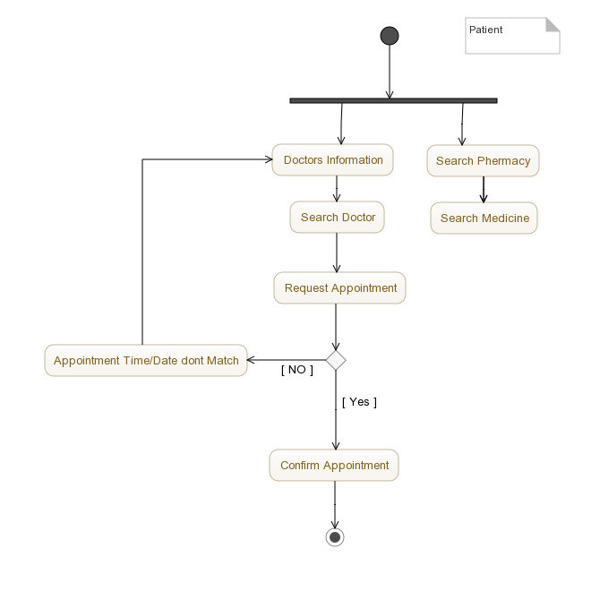

**Activity Diagram for Pharmacist**

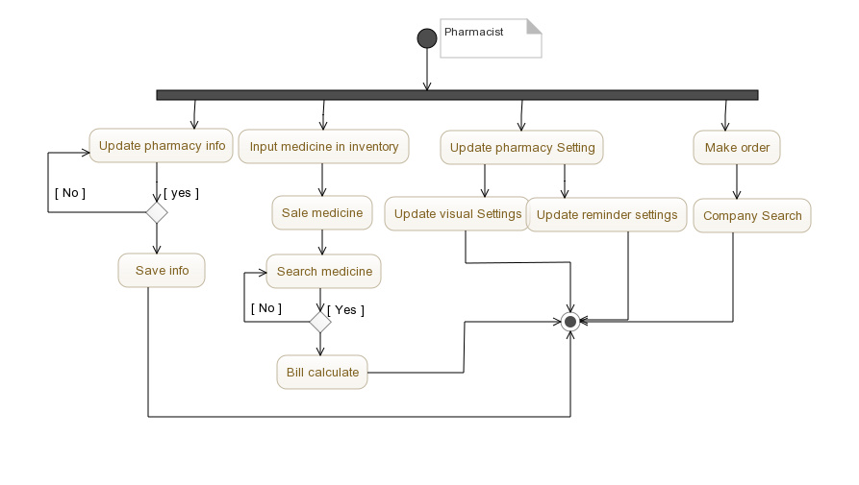

**Activity Diagram for Doctor:**

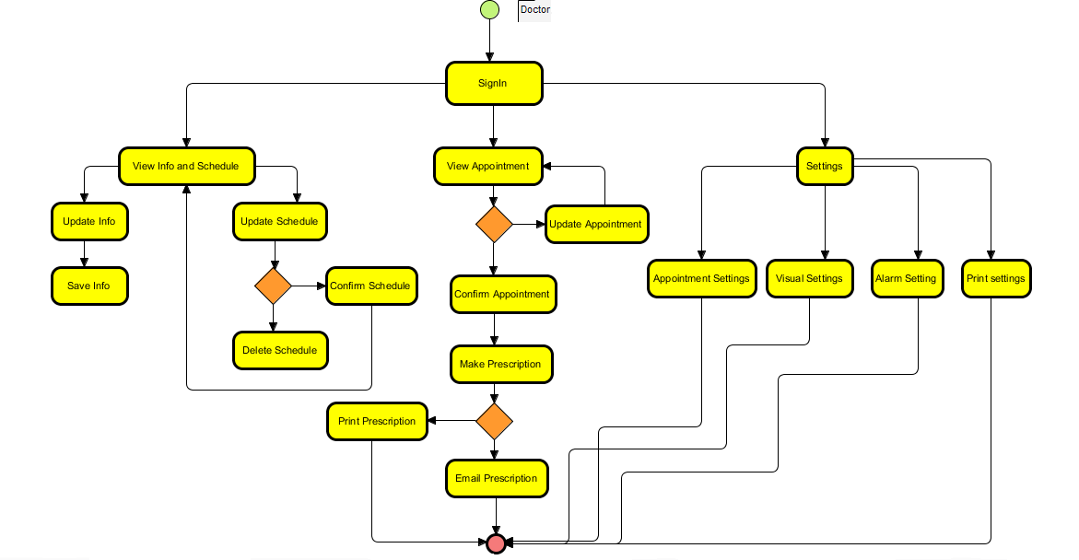

**Activity Diagram for Company:**

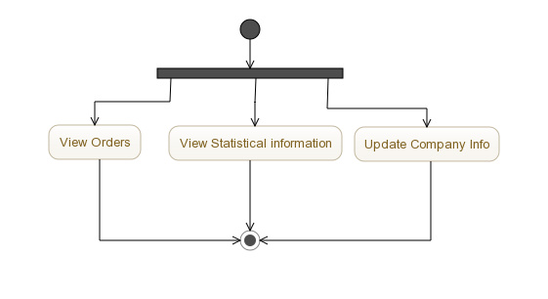

**Work Breakdown Structure (WBS)**

Precedence/Network Diagram:

|  |  |  |  |
| --- | --- | --- | --- |
| **Activity** | **Activity**  **Description** | **Duration (weeks)** | **Precedents** |
| A | Evolution | 2 | --------- |
| B | Identify stakeholders | 5 | _____ |
| C | Project sponsor reviews project charter | 3 | B |
| D | Create preliminary scope statement | 3 | A |
| E | Determine project team | 5 | C,D |
| F | Develop project plan | 4 | E |
| G | Submit project plan | 1 | F |
| H | Write user manuals | 10 | ------- |
| I | Verify and validate user requirement | 5 | H |
| J | Design system | 6 | I |
| K | Procure hardware/software | 3 | G,J |
| L | Install development system | 2 | K |
| M | Testing phase | 6 | J,L |
| N | Project management | 6 | M |
| O | Risk management | 3 | N |
| P | Update files/ records | 3 | O |
| Q | Gain formal acceptance | 1 | O,P |

|  |  |  |  |  |
| --- | --- | --- | --- | --- |
| 0 | 2 | | 2 | |
| **A** | | | | |
| 6 | | 6 | | 8 |

|  |  |  |  |  |
| --- | --- | --- | --- | --- |
| 5 | 3 | | 8 | |
| **D** | | | | |
| 8 | | 3 | | 11 |

|  |  |  |  |  |
| --- | --- | --- | --- | --- |
| 8 | 5 | | 13 | |
| **E** | | | | |
| 11 | | 3 | | 16 |

|  |  |  |  |  |
| --- | --- | --- | --- | --- |
| 13 | 4 | | 17 | |
| **F** | | | | |
| 16 | | 3 | | 20 |

|  |  |  |  |  |
| --- | --- | --- | --- | --- |
| 17 | 1 | | 18 | |
| **G** | | | | |
| 20 | | 3 | | 21 |

|  |  |  |  |  |
| --- | --- | --- | --- | --- |
| 5 | 3 | | 8 | |
| **C** | | | | |
| 13 | | 8 | | 16 |

|  |  |  |  |  |
| --- | --- | --- | --- | --- |
| 0 | 5 | | 5 | |
| **B** | | | | |
| 8 | | 8 | | 13 |

|  |  |  |  |  |
| --- | --- | --- | --- | --- |
| 21 | 3 | | 24 | |
| **K** | | | | |
| 21 | | 0 | | 24 |

|  |  |  |  |  |
| --- | --- | --- | --- | --- |
| 15 | 6 | | 21 | |
| **J** | | | | |
| 15 | | 0 | | 21 |

|  |  |  |  |  |
| --- | --- | --- | --- | --- |
| 10 | 5 | | 15 | |
| **I** | | | | |
| 10 | | 0 | | 15 |

|  |  |  |  |  |
| --- | --- | --- | --- | --- |
| 0 | 10 | | 10 | |
| **H** | | | | |
| 0 | | 0 | | 10 |

|  |  |  |  |  |
| --- | --- | --- | --- | --- |
| 24 | 2 | | 26 | |
| **L** | | | | |
| 24 | | 0 | | 26 |

|  |  |  |  |  |
| --- | --- | --- | --- | --- |
| 44 | 1 | | 45 | |
| **Q** | | | | |
| 44 | | 0 | | 45 |

|  |  |  |  |  |
| --- | --- | --- | --- | --- |
| 26 | 6 | | 32 | |
| **M** | | | | |
| 26 | | 0 | | 32 |

|  |  |  |  |  |
| --- | --- | --- | --- | --- |
| 32 | 6 | | 38 | |
| **N** | | | | |
| 32 | | 0 | | 38 |

|  |  |  |  |  |
| --- | --- | --- | --- | --- |
| 38 | 3 | | 41 | |
| **O** | | | | |
| 38 | | 0 | | 41 |

|  |  |  |  |  |
| --- | --- | --- | --- | --- |
| 41 | 3 | | 44 | |
| **P** | | | | |
| 41 | | 0 | | 44 |

**Critical Path is: H -> I -> J -> K -> L-> M -> N -> O -> P -> Q**

**Effort Estimation:**

As our software project type is “Embedded” so for calculating “effort estimation” we will consider the following data for ‘Coefficient’, ‘P’ and ‘T’.

|  |  |  |  |
| --- | --- | --- | --- |
| **Software Project Type** | **Coefficient**  **<Effort Factor>** | **P** | **T** |
| Embedded | 3.6 | 1.20 | 0.32 |

Our project SLOC= 1620.

Based on SLOC (source lines of code) characteristic, and operates according to the following equations:

* Effort = PM = Coefficient<Effort Factor>*(SLOC/1000)^P

= 3.6 * (1620/1000) ^1.20

= **6.4227**

* Development time = DM = 2.50*(PM)^T

= 2.50*(6.4227) ^0.32

= **4.5332**

* Required number of people = ST = PM/DM

= 6.4227/4.5332

= **1.4168**

**Where**:  
**PM** : person-months needed for project  
**SLOC** : source lines of code  
**P** : project complexity   
**DM** : duration time in months for project  
**T** : SLOC-dependent coefficient   
**ST** : average staffing necessary

Risk Management:

* Product size (PS)
* Business impact (BU)
* Customer characteristics (CU)
* Process definition (PR)
* Development Environment (DE)
* Technology to be built (TE)
* Staff size and experience (ST)
* **RMMM** = Risk Mitigation, Monitoring and Management Plan

**Impact values:**

* Catastrophic = **1**
* Critical = **2**
* Marginal = **3**
* Negligible = **4**

**Risk Table:**

|  |  |  |  |  |
| --- | --- | --- | --- | --- |
| Risks | Category | Probability | Impact | RMMM |
| 1. Failure of network connectivity with GPS(Global Path System) systems | PS | 40% | 2 | More logical mechanism may keep flawless network connectivity. |
| 2. Failure of internet connectivity with database systems | PS | 20% | 4 | Data will be stored in the user device. |
| 3. Lack of network access on device. | DE | 45% | 3 | Default application will consume very less data flow to avoid inability to use. |
| 4. Improper route planning. | CU | 10% | 3 | As soon as network access will recover route map will sync up. |
| 5. Conflict during execution of several routes to destination. | CU | 7% | 3 | Viewing of multi routes will defer by their different color. |
| 6. Lack of access to funding. | CU | 25% | 1 | Aims to secure funding for project before deadline. |
| 7. GPS navigator may not get update in certain criteria. | TE | 60% | 2 | Previous possible saved route map must be shown during that time |
| 8. There won’t be time in the QA process to validate equally on all cases from different operating systems. | PR | 45% | 2 | Planning needs to be more accurate to keep enough time for validation. |
| 9. Limited manpower to complete the project before deadline. | ST | 30% | 1 | Give attention about work distribution. |
| 10. Bugs in development tools. | DE | 28% | 3 | Implement robust preventive maintenance plans. |
| 11. Delivery deadline will be tightened | BU | 50% | 1 | Develop early delivery schedule. |
| 12. Staff inexperienced | ST | 35% | 3 | Train up by old staff |
| 13. Staff turnover will high | ST | 55% | 2 |  |
| 14. Release of more improved technology. | TE | 45% | 4 | Software does have scopes to adapt new technology following certain protocols. |

**“THE – END”**